Chapter 7: Surviving

7.1 The human body is divided into systems

Literacy support worksheet answers (pages 116–117)

Human body systems

1 On the lines to the right of each diagram, list the organs involved in each system using the organs below.

|  |  |  |  |  |  |  |  |
| --- | --- | --- | --- | --- | --- | --- | --- |
| *Brain* | *Nose* | *Muscles* | | *Blood* | *Stomach* | | *Mouth* |
| *Lungs* | *Small*  *Intestine* | *Heart* | | *Diaphragm* | *Oesophagus* | | *Large intestine* |
| *Liver* | *Veins* | *Spinal cord* | | *Windpipe* | *Bones* | | *Nerves* |
| Bones | | | Brain  Nerves  Spinal cord | | | Heart  Veins  Blood | |
| SKELETAL SYSTEM | | | NERVOUS SYSTEM | | | CIRCULATORY SYSTEM | |
| Lungs  Windpipe  Nose  Mouth  Diaphragm | | | Oesophagus  Stomach  Mouth  Liver  Small intestine  Large intestine | | | Muscles  Bones | |
| RESPIRATORY SYSTEM | | | DIGESTIVE SYSTEM | | | MUSCLE SYSTEM | |

2 Draw a flowchart showing the different levels of organisation in the body (refer to figure 7.2).

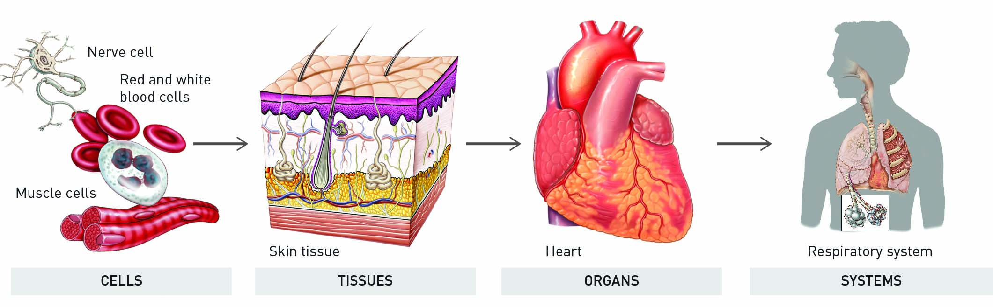

3 The first scientists lived in Alexandria during what time?

3rd century BCE

4 Why did they perform dissections?

To investigate how the human body worked

5 To prepare the body for mummification the Egyptians:

Removed key organs from the body.

6 What was da Vinci able to model from his investigations of the heart?

The aortic valve, the one-way valve in the main artery of the heart, using glass

7 List three advances that occurred due to the improvement in medical care in the 1700s.

• Smallpox vaccine

• Childbirth medicine

• Dental surgery

Word detective

8 Secret message

Use words from the Student Book to complete the puzzle. Then, use your answers to complete the sentence below.

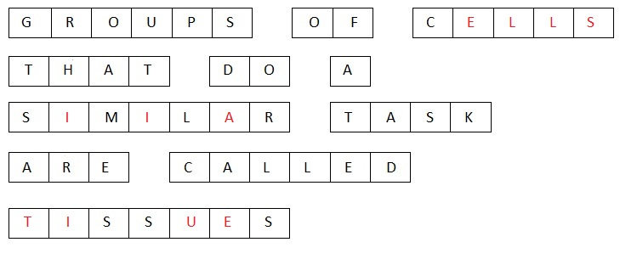Tissues are made of groups of cells that do a similar job, and groups of tissues that work together are called organs.

7.2 The digestive system is made up of organs

Literacy support worksheet answers (pages 118–119)

The digestive system

1 What is digestion?

Digestion is the process where foods are broken down and absorbed in to the blood to be transported to the cells.

2 Nutrients are substances that provide nourishment. How are nutrients transported through the body?

The blood pushes them through the body

3 Enzymes break down food in the mouth. What sort of digestion is this?

Chemical digestion

4 A biting motion also breaks down food in the mouth. What sort of digestion is this?

Mechanical digestion

5 Label the following diagram of the mouth and state the function of each type of tooth.

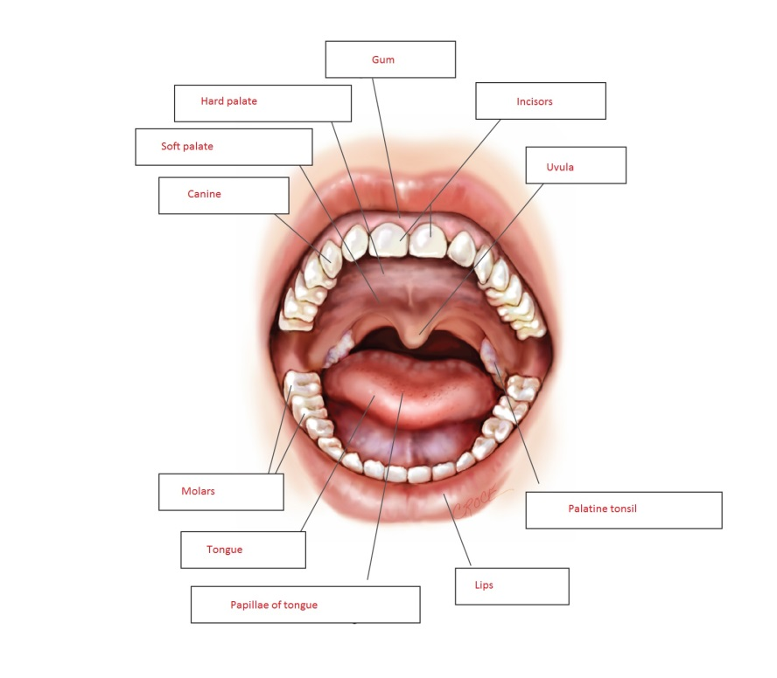

6 Label the following diagram of the digestive system:

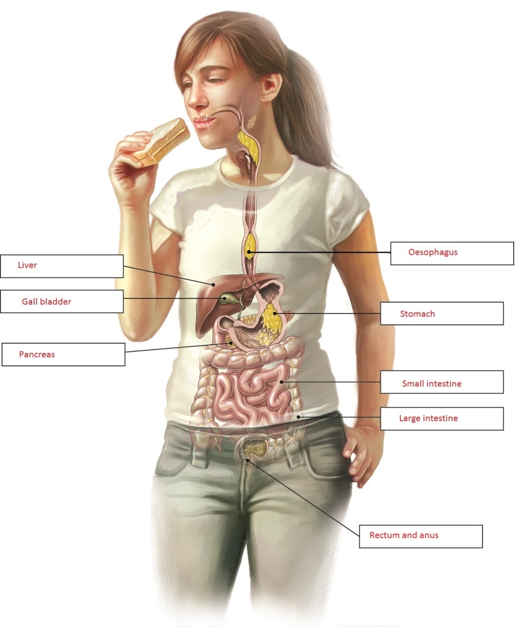

Word detective

7 Matching meaning

Draw a line to match the organ on the left with the appropriate description of its function, on the right.

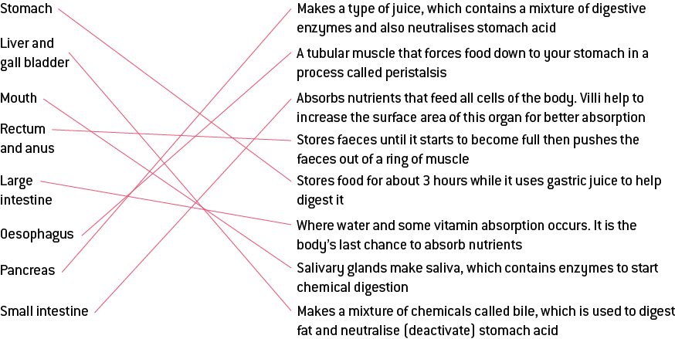

7.3 The digestive system varies between animals

Literacy support worksheet answers (pages 120–121)

The digestive systems of various animals

1 Describe each of the different types of teeth:

a Incisors

Have a sharp knifelike structure, and are used to cut through food.

b Canine

Teeth are pointed, and are useful in ripping lumps of meat apart.

c Molars

Are flatter and are especially good at grinding plants into small pieces.

2 How would a palaeontologist know what an animal from the past ate?

They look at their teeth to see what they ate.

3 What lives in the caecum?

Bacteria

4 Why is this organism needed?

To break down the cellulose in plants so they can be digested

5 Some animals eat their own faeces to gain extra nutrients. Give four examples of animals who do this:

Possums, rabbits, rodents and termites eat their own faeces to get extra nutrients.

6 Draw a diagram of a cow’s digestive system:

Student diagrams will vary.

7 What is a ruminant?

A ruminant converts grass and other foods into protein and energy using a four-compartment stomach.

8 Which other animals are also ruminants?

Sheep and goats are also ruminants.

9 Match the following organs (the words on the left) in a cow’s digestive system to its function (the descriptions on the right). You may refer to page 121 of the student book to help with this task, if needed.

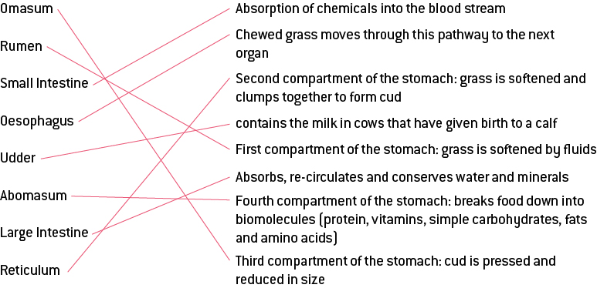

Word detective

10 Order us!

The following sentences describe the process of a cow’s digestion. Place them in the correct order, by writing a number from 1 to 5 beside each one.

(5) Abomasum – has acid and enzymes like a human stomach

(1) Rumen – grass is swallowed and goes here.

(3) Recticulum – involved in trapping any unwanted things the cow may have swallowed

(2) The grass is regurgitated and is chewed over and over again.

(4) Omasum – has many leaf-like folds that filter fine particles

7.4 Science as a human endeavour: Things sometimes go wrong in the digestive system

Literacy support worksheet answers (pages 122–123)

Problems in the digestive system

Stomach ulcers:

1 Which digestive organ do stomach ulcers form in?

Stomach

2 What is the name of the bacteria that causes of stomach ulcers?

Spiral-shaped bacteria, called *Helicobacter pylori*

3 How do patients feel when they have a stomach ulcer and why?

A great deal of pain in their stomach

Gallstones:

4 Finish the sentence:

Occasionally parts of the bile harden into a small stone that stops:

the bile leaving the gallbladder and the gallbladder swells up.

5 What effect does a gallstone have on your body?

Severe stomach pains

6 What are three ways gallstones can be treated?

Shattered by ultrasound

Removed by surgery

The gallbladder may have to be removed

Gluten intolerance:

7 What are the symptoms of gluten intolerance?

Blockages of the intestines and diarrhoea (watery faeces)

8 What is gluten intolerance?

When the body is unable to produce the enzyme which breaks down gluten

9 What parts of the body can gluten intolerance affect?

Gluten cannot be digested and causes stomach pains, blockages and diarrhoea.

10 What is the treatment for gluten intolerance?

Do not eat gluten.

Constipation:

11 Which part of the body is blocked when constipation occurs?

Large intestine

12 What effect does constipation have on your body?

Severe abdominal cramps/pain/discomfort

13 What is the treatment for constipation?

Sometimes medication is needed to move the blockage. If it is not treated, the person may die.

Word detective

14 Crossword

Read the clues and fill in the crossword below.

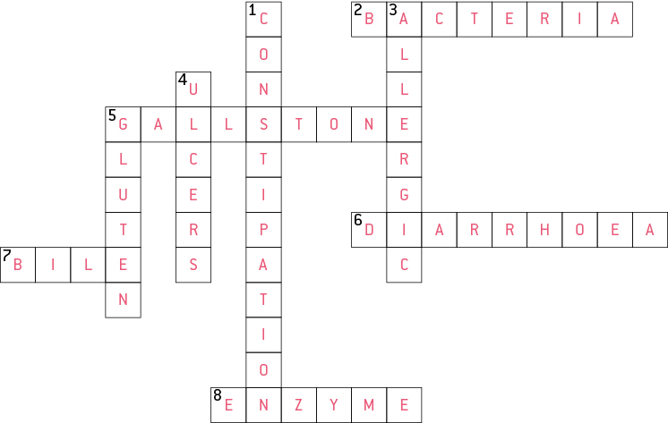

7.5 The respiratory system exchanges gases

Literacy support worksheet answers (pages 124–125)

The respiratory system

1 What is the role of the respiratory system?

It gives the cells in your body the oxygen they need, and removes carbon dioxide.

2 What is the process of using oxygen to release energy in cells called?

Cellular respiration

3 How is it oxygen transported to the lungs? Draw a horizontal flow diagram to show this:

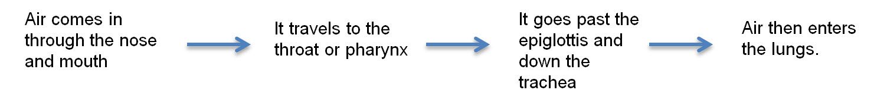4 What are the alveoli?

They are air sacs within the lungs that are covered in capillaries and transport oxygen into the blood.

5 Draw and label diagram of how the trachea, bronchi, bronchiole and air sacs (alveoli) look together. Use figure 7.9 to in Oxford Science 8 to help you.

Student answers will vary – see figure 7.9 in the Student Book for diagram.

6 What is the diaphragm?

It is a dome-shaped muscle which lifts the rib cage to allow the lungs to fill and deflate.

7 What do the muscles in the diaphragm do when you:

a Breathe in (inhalation)

The diaphragm relaxes up to allow lungs to inflate.

b Breathe out (exhalation)

The diaphragm contracts down to squeeze air out of the lungs, allowing deflation.

8 Label the following diagram of the respiratory system:

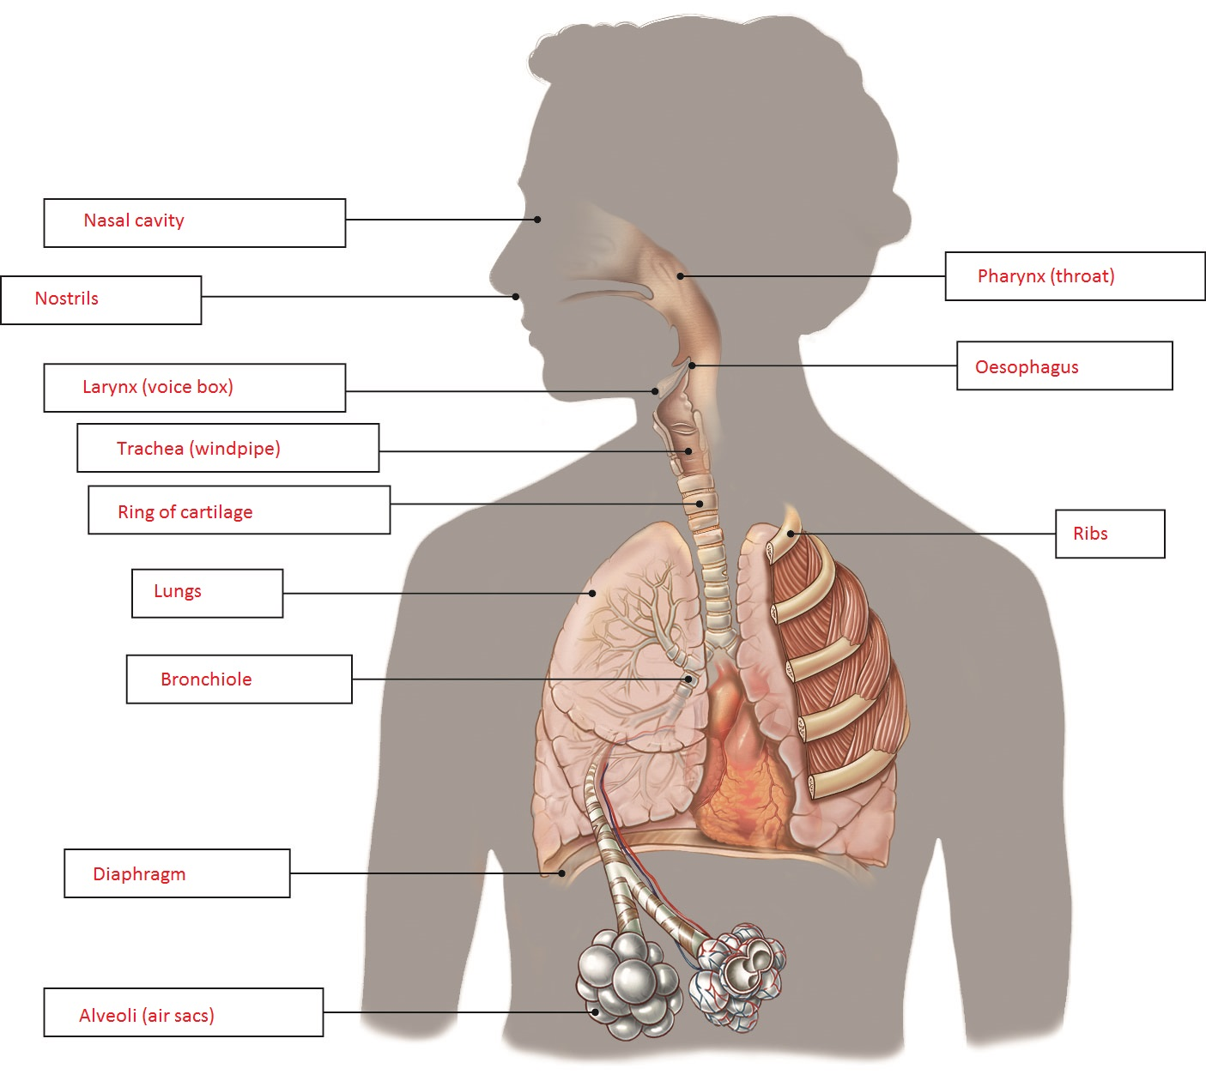

Word detective

9 Draw and label

Draw and label a diagram of the capillaries. Use figure 7.19 to help you. Include the labels:

• Oxygen moves from air to blood.

• Blood from body contains carbon dioxide.

• Carbon dioxide moves from blood into air.

• Blood contains oxygen, moves into body.

Student answers will vary – see figure 7.19 in the Student Book for diagram.

7.6 Science as a human endeavour: Things sometimes go wrong in the respiratory system

Literacy support worksheet answers (pages 126–127)

Problems in the respiratory system

Coughing and sneezing:

1 Name four things that can go wrong with the respiratory system:

• Coughing

• Asthma

• Emphysema

• Pneumonia

2 In which respiratory organ/s does coughing and sneezing occur?

In the organs of the upper airway – the nose and throat.

3 What is the cause of coughing?

Small cilia trap larger particles and want to push them back to the top of the throat to be swallowed. The diaphragm contracts quickly in response to large particles making us cough them up.

4 Draw a flow diagram showing how the brain registers a sneeze and where the message goes:

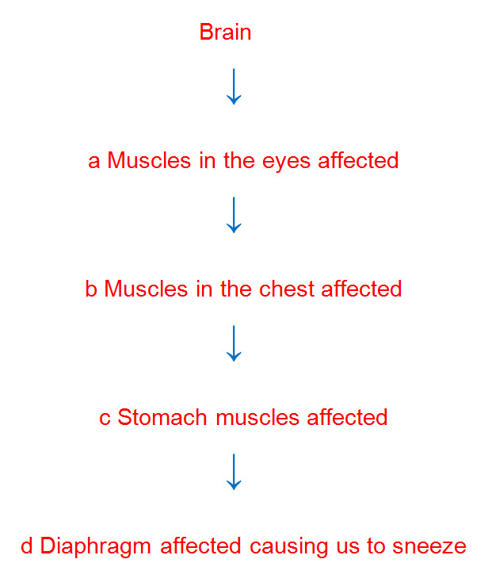

5 How fast are some sneezes?

Up to 120 km per hour

Asthma:

6 How many Australians does asthma affect?

It affects one in every ten Australians.

7 In which respiratory organ does asthma occur?

Bronchi and bronchioles

8 Draw a quick flow diagram outlining how asthma is caused and the flow on effects:

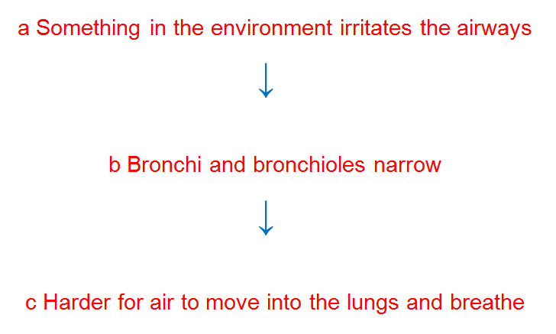

9 What is the treatment for asthma?

A drug called Ventolin is used to relax the airways.

Emphysema:

10 What is the cause of emphysema?

The cause of smoking is as follows: Smoking breathes tar into your lungs. Tar covers the inside of the alveoli like honey, stopping oxygen from moving into the blood. Alveolar sacs are killed by chemicals, and the body is not able to move air in and out.

11 How does emphysema affect the body?

It causes the sufferer to struggle to breathe, and therefore to walk even short distances.

12 What do you think is a logical treatment for emphysema?

Stop smoking – quit!

Pneumonia:

13 What is the cause of pneumonia?

Pneumonia is caused by a bacterial or viral infection.

14 What effect does pneumonia have on your body?

The alveoli in the lungs fill up with bacteria, pus and fluid. This prevents air moving into the lungs. It makes it very difficult to breathe, sometimes resulting in death if not treated.

15 What is the treatment for pneumonia?

The treatment is antibiotics to kill the bacteria.

Word detective

16 Fill in the gaps

Fill the gaps in the sentences below, using the words provided.

throat cilia particles bronchioles

chest diaphragm nose cells

Every time you breathe in, you take in small particles of dust, pollen and other particles. Small cilia on the surface of the cells trap these particles and push them to the top of the throat where they are swallowed. Larger particles trigger the diaphragm making us cough. This pushes up the large particle before it enters the bronchioles. Sneezes happen when particles get trapped by the hairs in our nose. A message is then sent to the brain which controls the muscles in the eyes, chest, stomach and diaphragm, making us sneeze.

7.7 The circulatory system carries substances around the body

Literacy support worksheet answers (pages 128–129)

The circulatory system

1 What does the circulatory system do?

It moves blood around the body to transport nutrients and wastes.

2 What is the heart?

The heart is a large two-part pump about the size of your fist.

3 How many chambers are there in a human heart?

There are four chambers in the human heart.

4 Label the diagram of the heart and draw arrows to show how the blood flows through each part.

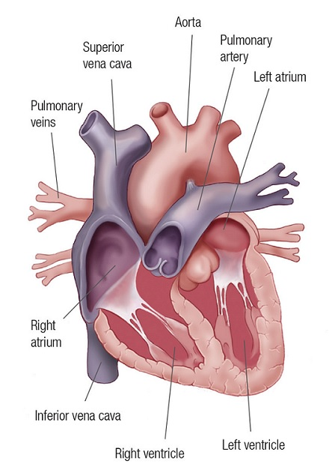

5 What are the top chambers called?

Atriums

6 What are the bottom chambers called?

Ventricles

7 Which side pumps blood to the lungs?

The right side

8 Which side pumps blood around the body?

The left side

9 Draw a line to match each component of blood, from the words on the left, to its function, on the right.

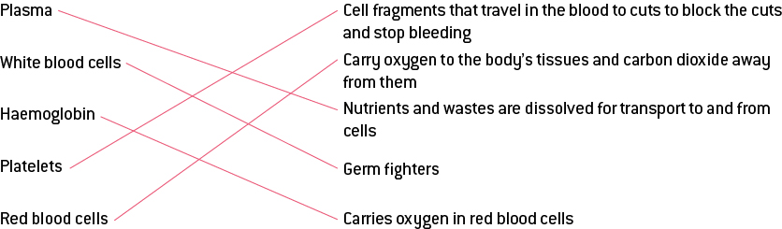

10 Which type of blood vessel carries blood toward the heart?

Veins

11 Which type of blood vessel carries blood away from the heart?

Arteries

12 Why do capillaries have cell walls that are only one cell thick?

This is to allow substances to easily pass in and out of blood.

13 What do the capillaries connect to?

They connect to arteries and veins.

Word detective

14 True or false

Read the statement and circle whether it is true or false.

a The heart is about the size of your fist.

T

b Valves keep the blood moving in the right direction.

T

c Oxygen is carried by white blood cells.

F

d Red blood cells kill bacterial cells.

F

e Platelets are cell fragments that fix blood vessels.

T

f Capillaries are the largest blood vessels

F

g Arteries are only one cell thick.

F

7.8 Science as a human endeavour: Things sometimes go wrong in the circulatory system

Literacy support worksheet answers (pages 130–131)

Problems in the circulatory system

Valve disease

1 What are three ways that the heart valves can become damaged?

They can leak (valve disease).

The vessels can narrow (atherosclerosis).

The cells in the heart can die in a heart attack.

2 What are the effects of valve disease?

Blood doesn’t flow properly around the body, and less oxygen and nutrients get carried to the cells.

3 What is a symptom of valve disease?

Constant tiredness

Atherosclerosis

4 In which cardiovascular organ does atherosclerosis occur?

The blood vessels

5 What is the cause of atherosclerosis?

A narrowing of blood vessels is caused by a build-up of plaque on the inside of the arteries and veins. Layers of plaque (consisting of fat, cholesterol and other substances) are laid down over time.

6 Name three things that plaque consists of:

• Fat

• Cholesterol

• Other substances found in the blood

7 What effect does atherosclerosis have on your body?

The plaque hardens and restricts blood flow. If in the heart, it causes a heart attack.

Coronary heart disease

8 What is the cause of coronary heart disease?

Fatty deposits blocking important blood vessels in the heart causes coronary heart disease.

9 What effect does coronary heart disease have on your body?

Vessels become completely blocked or a bit of the fatty deposit breaks off and travels into the heart. Heart muscle cells may be killed in the process. It may cause heart attack.

10 What are two ways to avoid coronary heart disease?

• Eating less fatty food

• Regular exercise

Pericarditis

11 What is the pericardium?

It is a thin sac that surrounds the heart to make it move easily when it beats.

12 What is the cause of pericarditis? Finish the sentence below:

When the pericardium becomes**:**

Infected by bacteria causing it to fill with liquid.

13 What effect does pericarditis have on your body?

The heart cannot beat properly as it cannot completely fill with blood.

Word detective

14 Draw and label

Draw and label a diagram of a blocked artery and a dying heart muscle. Use figure 7.31 to help you.

Include these labels:

Artery Blood clot Coronary arteries Healthy muscle Dying muscle

Student answers may vary – see figure 7.31 in Oxford Science 8 Western Australian Curriculum for the diagram.

7.9 The excretory system removes waste

Literacy support worksheet answers (pages 132–133)

The excretory system

1 What does the excretory system do?

It removes waste products from the body which are produced in the digestive and respiratory systems.

2 Name the organs of excretion:

• Kidney

• Liver

• Lungs

• Skin

3 Why is water important in controlling wastes?

It dilutes harmful substances and moves substances, and keeps body temperature at the right level.

4 Label the organs involved in the excretory system below:

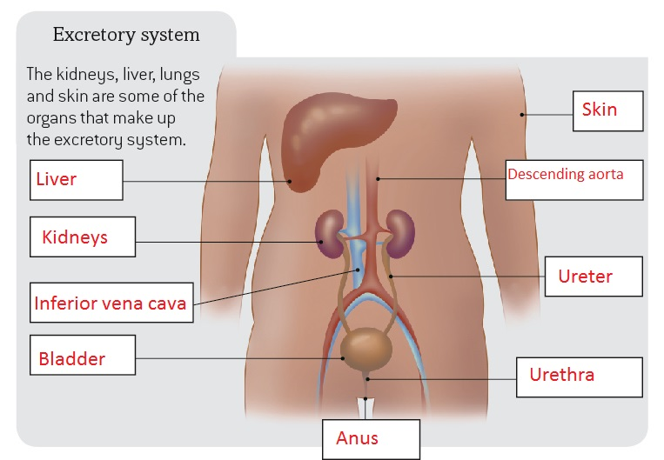

5 Label the main parts of a kidney below, including where waste enters and exits and where clean blood exits.

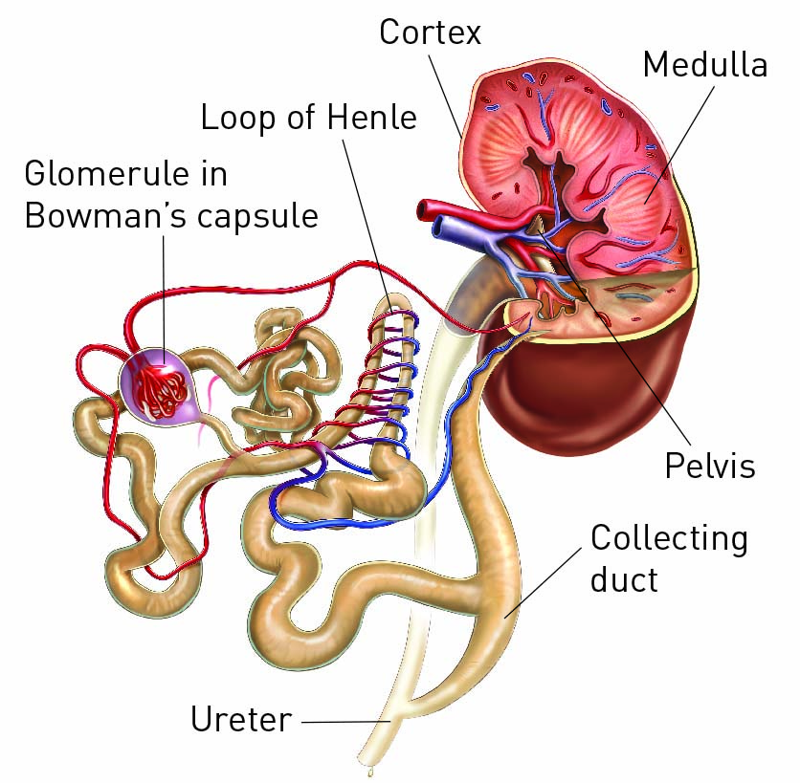

6 Describe the body’s five step process to digest (metabolise) proteins:

a The body breaks down proteins into amino acids.

b The liver breaks down amino acids for energy.

c Ammonia is produced.

d The liver changes ammonia into urea.

e Urea is filtered by the kidneys for removal.

7 What does the liver do in the excretory system?

It removes toxins, makes proteins, allows blood to clot and makes bile.

Word detective

8 Boggle

Find and circle as many words as you can about the excretory system in the puzzle below. The words can run up and down or left to right as well.

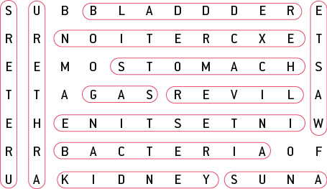

7.10 Plants have tissues and organs

Literacy support worksheet answers (pages 134–135)

Plant systems

1 Name three specialised organs found in plants:

• Roots

• Stems

• Leaves

2 Name three things that roots do:

• Anchor the plant to the soil

• Absorb nutrients

• Absorb water

3 What is the role of the stem in a plant?

The stem transports water and nutrients between the roots and leaves.

4 What is the function of leaves in a plant?

They exchange gases, produce sugars through photosynthesis and control water loss.

5 What is the role of the vascular bundle in the stem?

It is the ‘road’ that water and nutrients use to move around the plant.

6 Label the vascular bundle below. Use figure 7.41 to help you.

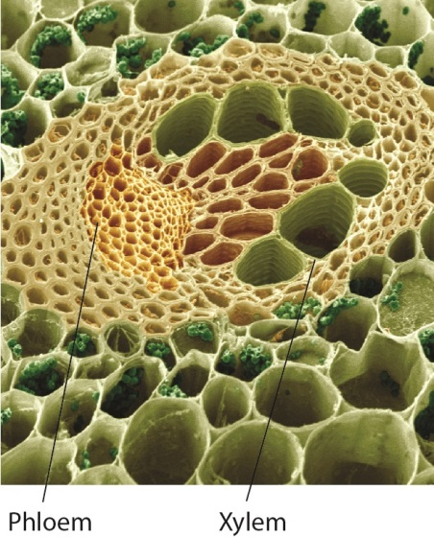

7 Label the stoma below, including where air moves in and out.

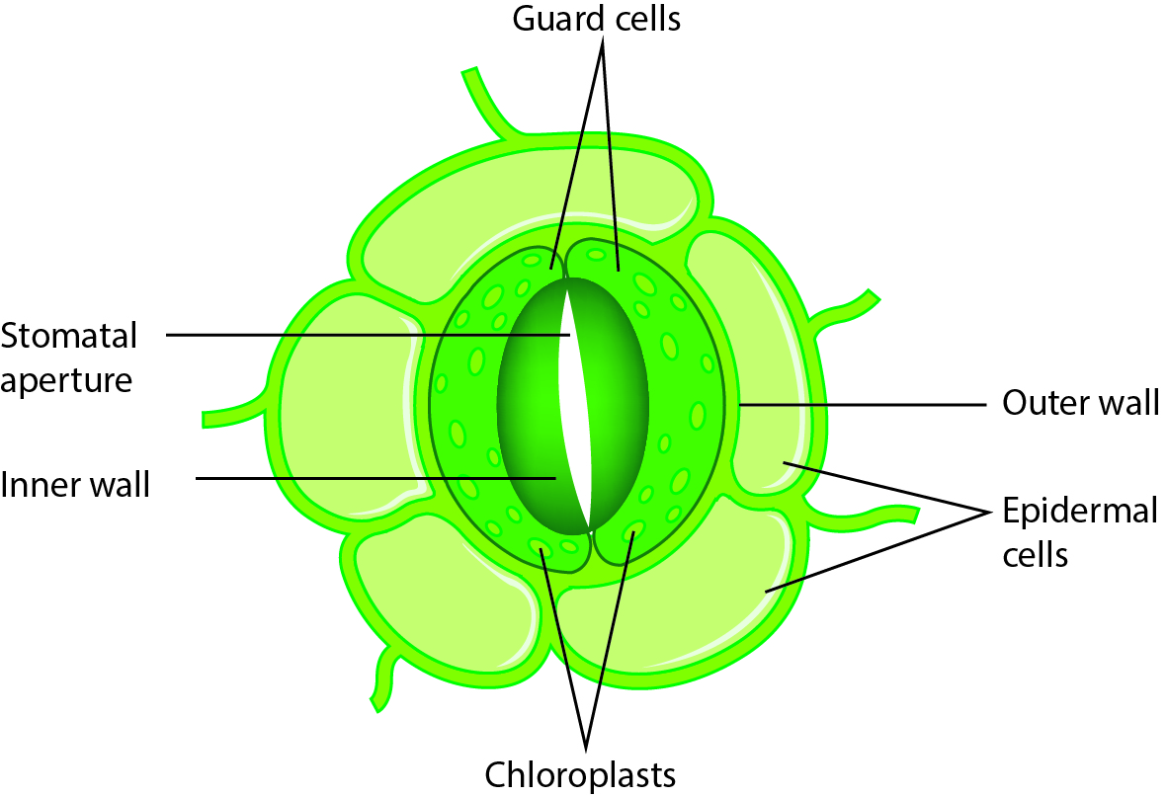

8 What moves in and out of the cells through the stomata?

Carbon dioxide and water

9 How do the guard cells of the stomata stop the plant from losing too much water?

When it becomes hot the guard cells become smaller, closing the pores in the plant’s stomata and preventing water vapour escaping.

Word detective

10 Order us!

Number each of the sentences below to place them in order, showing the correct sequence of what happens in the osmosis process in roots.

(3) The inside of the roots become more salty than the soil.

(4) Water molecules are attracted to the mineral salts in the root cells.

(1) Roots take in mineral salts from the soil

(5) Water moves through the root cell membrane and into the plant

(2) Roots store the mineral salts in their cells